**Planning:-**

Planning is considered the first primary function of management. In this function, managers define the organizational goals and allocate resources to the organization to achieve such goals. So planning will also define all the future functions of management.

**Organizational planning:-**

Organizational planning is the process of defining a company’s reason for existing, setting goals aimed at realizing full potential, and creating increasingly discrete tasks to meet those goals.

Each phase of planning is a subset of the prior, with strategic planning being the foremost

There are four phases of a proper organizational plan: strategic, tactical, operational, and contingency. Each phase of planning is a subset of the prior, with strategic planning being the foremost.

**Types of Organizational Planning:-**

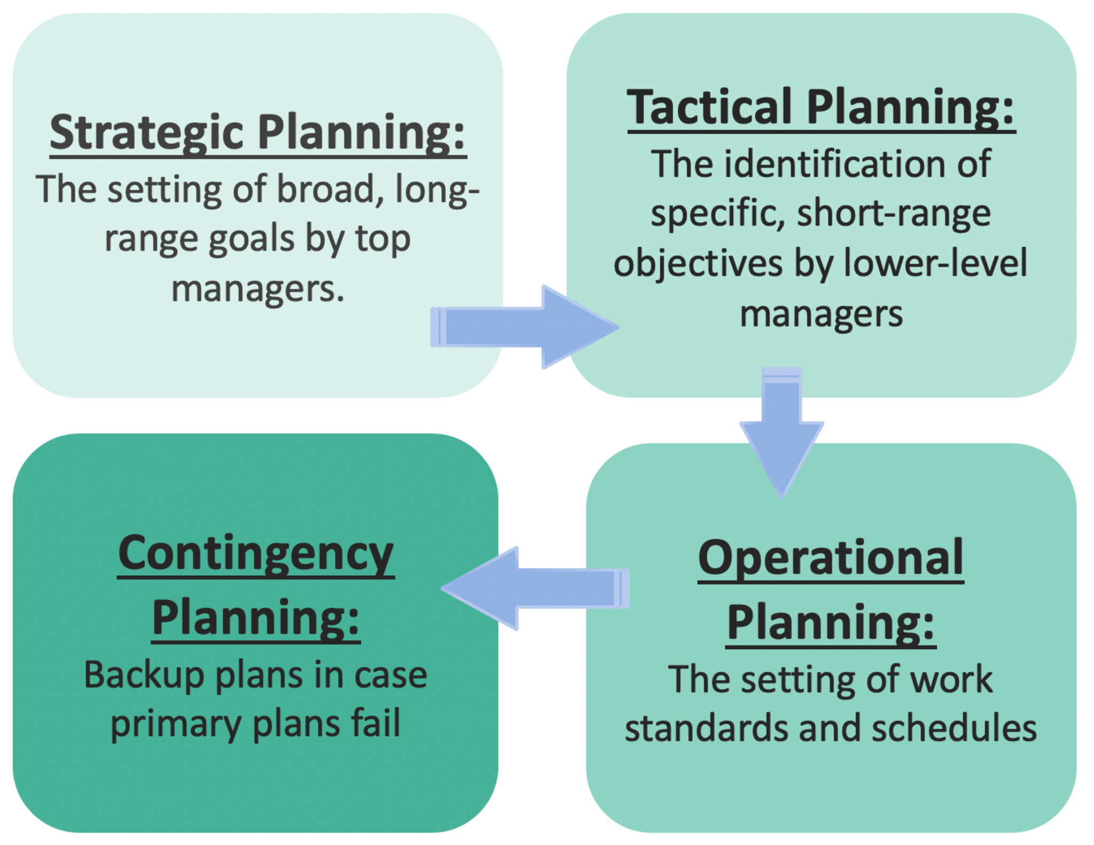

**Strategic**

A strategic plan is the company’s big picture. It defines the company’s goals for a set period of time, whether that’s one year or ten, and ensures that those goals align with the company’s mission, vision, and values. Strategic planning usually involves top managers, although some smaller companies choose to bring all of their employees along when defining their mission, vision, and values.

**Tactical**

The tactical strategy describes how a company will implement its strategic plan. A tactical plan is composed of several short-term goals, typically carried out within one year, that support the strategic plan. Generally, it’s the responsibility of middle managers to set and oversee tactical strategies, like planning and executing a marketing campaign.

**Operational**

Operational plans encompass what needs to happen continually, on a day-to-day basis, in order to execute tactical plans. Operational plans could include work schedules, policies, rules, or regulations that set standards for employees, as well as specific task assignments that relate to goals within the tactical strategy, such as a protocol for documenting and addressing work absences.

**Contingency**

Contingency plans waiting in the wings in case of a crisis or unforeseen event. Contingency plans cover a range of possible scenarios and appropriate responses for issues varying from personnel planning to advanced preparation for outside occurrences that could negatively impact the business. Companies may have contingency plans for things like how to respond to a natural disaster, malfunctioning software, or the sudden departure of a C-level executive.

**The organizational planning process includes five phases that, ideally, form a cycle.**

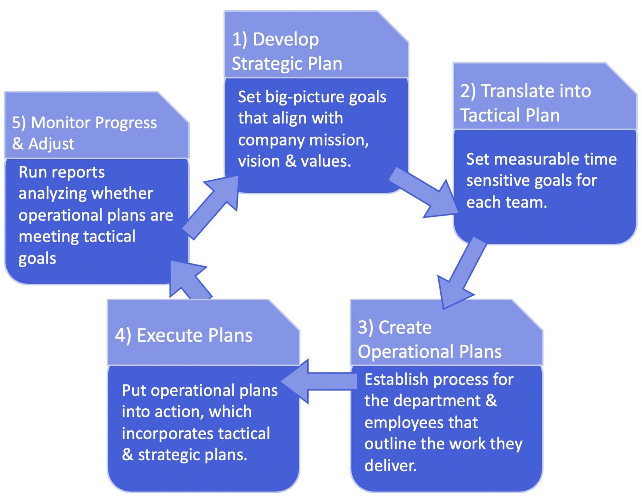

Strategic, tactical, operational, and contingency planning fall within these five stages.

**1. Develop the strategic plan**

Steps in this initial stage include:

* Review your mission, vision, and values
* Gather data about your company, like performance-indicating metrics from your sales department
* Perform SWOT analysis; take stock of your company’s strengths, weaknesses, opportunities, and threats
* Set big picture goals that take your mission, vision, values, data, and SWOT analysis into account

**2. Translate the strategic plan into tactical steps**

At this point, it’s time to create tactical plans. Bring in middle managers to help do the following:

* Define short-term goals—quarterly goals are common—that support the strategic plan for each department, such as setting a quota for the sales team so the company can meet its strategic revenue goal
* Develop processes for reviewing goal achievement to make sure strategic and tactical goals are being met, like running a CRM report every quarter and submitting it to the Chief Revenue Officer to check that the sales department is hitting its quota
* Develop contingency plans, like what to do in case the sales team’s CRM malfunctions or there’s a data breach

**3. Plan daily operations**

Operational plans, or the processes that determine how individual employees spend their day, are largely the responsibility of middle managers and the employees that report to them. For example, the process that a sales rep follows to find, nurture, and convert a lead into a customer is an operational plan.

This stage should include setting goals and targets that individual employees should hit during a set period.

Managers may choose to set some plans, such as work schedules, themselves. On the other hand, individual tasks that make up a sales plan may require the input of the entire team. This stage should also include setting goals and targets that individual employees should hit during a set period.

**4. Execute the plans**

It’s time to put plans into action. Theoretically, activities carried out on a day-to-day basis (defined by the operational plan) should help reach tactical goals, which in turn supports the overall strategic plan.

**5. Monitor progress and adjust plans**

No plan is complete without periods of reflection and adjustment. At the end of each quarter or the short-term goal period, middle managers should review whether or not they hit the benchmarks established in step two, then submit data-backed reports to C-level executives.

**Planning Process**

The planning function of management is one of the most crucial ones. It involves setting the goals of the company and then managing the resources to achieve such goals. As you can imagine it is a systematic process involving eight well-thought-out steps. Let us take a look at the planning process.

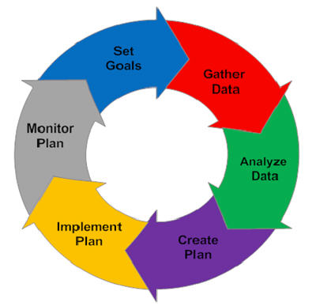

**1] Recognizing Need for Action**

An important part of the planning process is to be aware of the business opportunities in the firm’s external environment as well as within the firm. Once such opportunities get recognized the managers can recognize the actions that need to be taken to realize them.

**2] Setting Objectives**

This is the second and perhaps the most important step of the planning process. Here we establish the objectives for the whole organization and also individual departments. Organizational objectives provide a general direction, objectives of departments will be more planned and detailed.

Objectives can be long-term and short-term as well. They indicate the end result the company wishes to achieve. So objectives will percolate down from the managers and will also guide and push the employees in the correct direction

**3] Developing Premises**

Planning is always done keeping the future in mind, however, the future is always uncertain. So in the function of management certain assumptions will have to be made. These assumptions are the premises. Such assumptions are made in the form of forecasts, existing plans, past policies, etc.

These planning premises are also of two types – **internal and external**.

**External** assumptions deal with factors such as political environment, social environment, the advancement of technology, competition, government policies, etc.

**Internal** assumptions deal with policies, availability of resources, quality of management, etc.

**4] Identifying Alternatives**

The fourth step of the planning process is to identify the alternatives available to the managers. There is no one way to achieve the objectives of the firm, there is a multitude of choices. All of these alternative courses should be identified. There must be options available to the manager.

**5] Examining Alternate Course of Action**

The next step of the planning process is to evaluate and closely examine each of the alternative plans. Every option will go through an examination where all its pros and cons will be weighed. The alternative plans need to be evaluated in light of the organizational objectives.

**6] Selecting the Alternative**

Finally, we reach the decision-making stage of the planning process. Now the best and most feasible plan will be chosen to be implemented. The ideal plan is the most profitable one with the least amount of negative consequences and is also adaptable to dynamic situations.

The choice is obviously based on scientific analysis and mathematical equations. But a manager's intuition and experience should also play a big part in this decision.

**7] Formulating Supporting Plan**

Once you have chosen the plan to be implemented, managers will have to come up with one or more supporting plans. These secondary plans help with the implementation of the main plan. For example plans to hire more people, train personnel, expand the office, etc are supporting plans for the main plan of launching a new product. So all these secondary plans are in fact part of the main plan.

**8] Implementation of the Plan**

And finally, we come to the last step of the planning process, the implementation of the plan. This is when all the other functions of management come into play and the plan is put into action to achieve the objectives of the organization. The tools required for such implementation involve the types of plans- procedures, policies, budgets, rules, standards, etc.

**Characteristics of Control Process:-**

* Control is the function of every manager. Managers at all levels have to perform this function to contribute to the achievement of organizational objectives.
* Control leads to the appraisal of past activities. The deviations in the past are revealed by the control process. Corrective actions can be initiated accordingly.
* Control is concerned with setting standards, measurement of actual performance, comparison of actual performance with predetermined standards, and bringing to light the variations between the actual performance and the standard performance.
* Control implies taking corrective measures. The object in checking the variations or deviations is to rectify them and prevent their recurrence. It is the only action that adjusts performance to predetermined standards whenever deviations occur.
* Control can be exercised only with reference to and or the basis of plans. To quote Mary Cushing Niles - "Whereas planning sets the course, control observes deviations from the course or to an appropriately changed one".
* To some people, control is the opposite of freedom. This is not true. Control is based on facts and figures. Its purpose is to achieve and maintain acceptable productivity from all resources of an enterprise. Therefore, control aims at results and not at persons. It is for correcting a situation, and not for reprimanding persons.
* Information or feedback is the guide to control. The feedback is helpful to the manager to determine how far the operations are proceeding in conformity with plans and standards, and where remedial action is called for.
* Control involves a continuous review of standards of performance and results in-corrective action which may lead to change in the performance of other functions of management. This makes control a dynamic and flexible process.
* Control is a continuous activity. It involves constant analysis of the validity of standards, policies, procedures, etc.

**MIS-System development life cycle:-**

It's a common phenomenon that any organization that wants to create a new system like machine, tool, logical or physical system, create the system in such a way so that it will have its long life. To create a new system with its long life, an expert member (system analyst) follows some phases, these phases are known as SDLC phases. The SDLC phases are as follows

1. Problem identification
2. Requirement analysis
3. System design
4. Implementation
5. Testing
6. Deployment
7. Maintenance

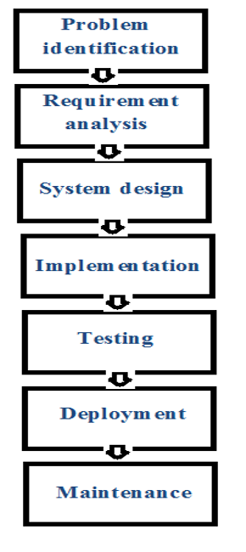

### **1) Problem identification**

This is the first and initial phase of SDLC. In this phase, the analyst, identify the actual problem for which they want a solution or create a system. The main concern of this phase is to recognize the real problem, if the problem is significant then the solution will be useful otherwise the solution will not be fruitful or it will be useless. If the experts work on the unrealistic problem then the solution is a waste of time, effort, costs, etc. So, the problem must be realistic. To identify the problem, the analyst pays more attention to it.

**2) Requirement analysis**

After getting the problem identification, the next step is to work on requirement analysis. In requirement gathering, the analyst thinks about the solution to a problem. The requirement analysis is a detailed analysis that includes the answer to different questions like –

What is the problem?

What is the solution?

Is the solution feasible?

How much time is required to solve the problem?

These are the few key questions for which an analyst finds real solutions. It shows the proper planning to get all solutions in our hands before solving the actual problem. Without proper planning or without knowing the actual problem to work upon its solution or implement a system always fails.

### **3) System design**

System design is a blueprint of the solution. It is similar to before making a car the designers make a sketch of the car and then connect all parts of the car according to its predefined design.

**4) Implementation**

The implementation shows the final integration of the system. Implementation describes how the product will get converted into its final form. There are different components associated with the system and during the implementation process, all parts of the system are linked with one another according to a proper plan so that they can work properly and fulfill the objective of the system.

**5) Testing**

Testing is a process to validate the objective of the system through various steps. It is a mechanism that makes sure that the system is working properly or not. After the implementation of the system, it is tested on different aspects. Different inputs are given and test the output accuracy.

**6) Deployment**

After successful testing of the developed system, it is deployed to the concerned candidate or company for which it has been designed. Deployment is the process to deploy the newly designed system at the clients/customers end.

**7) Maintenance**

Maintenance is the last and one of the most important phases of SDLC. Maintenance of the system gives long life to the new system. After the successful deployment of the system at the client's end, it is compulsory to maintain it from time to time.